Image | Artist | Title | Dimensions | Year | Medium
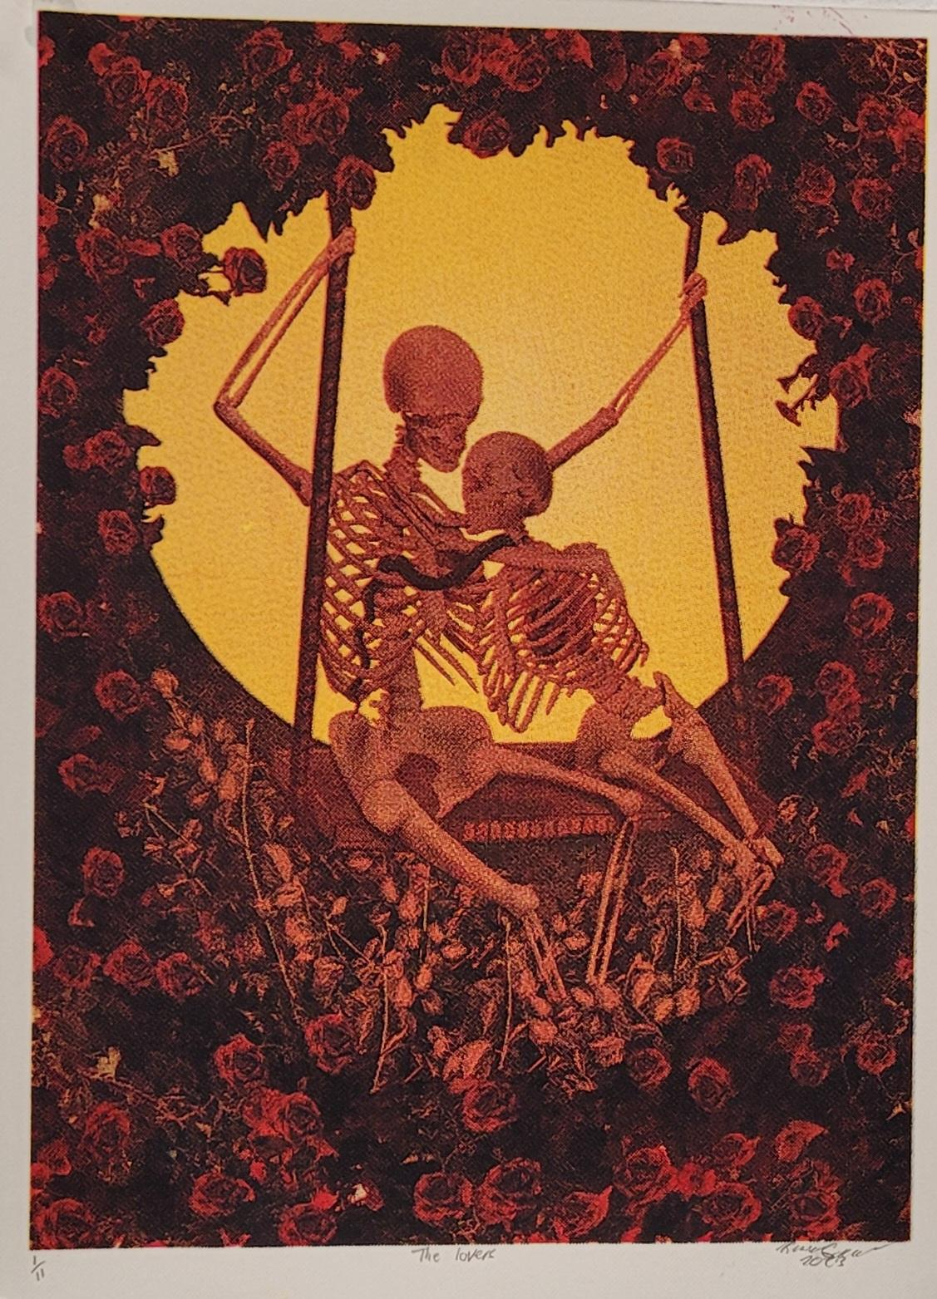 | Kendell Gunderson | The Love | 9x12 inches | 2023 | Silk Screen
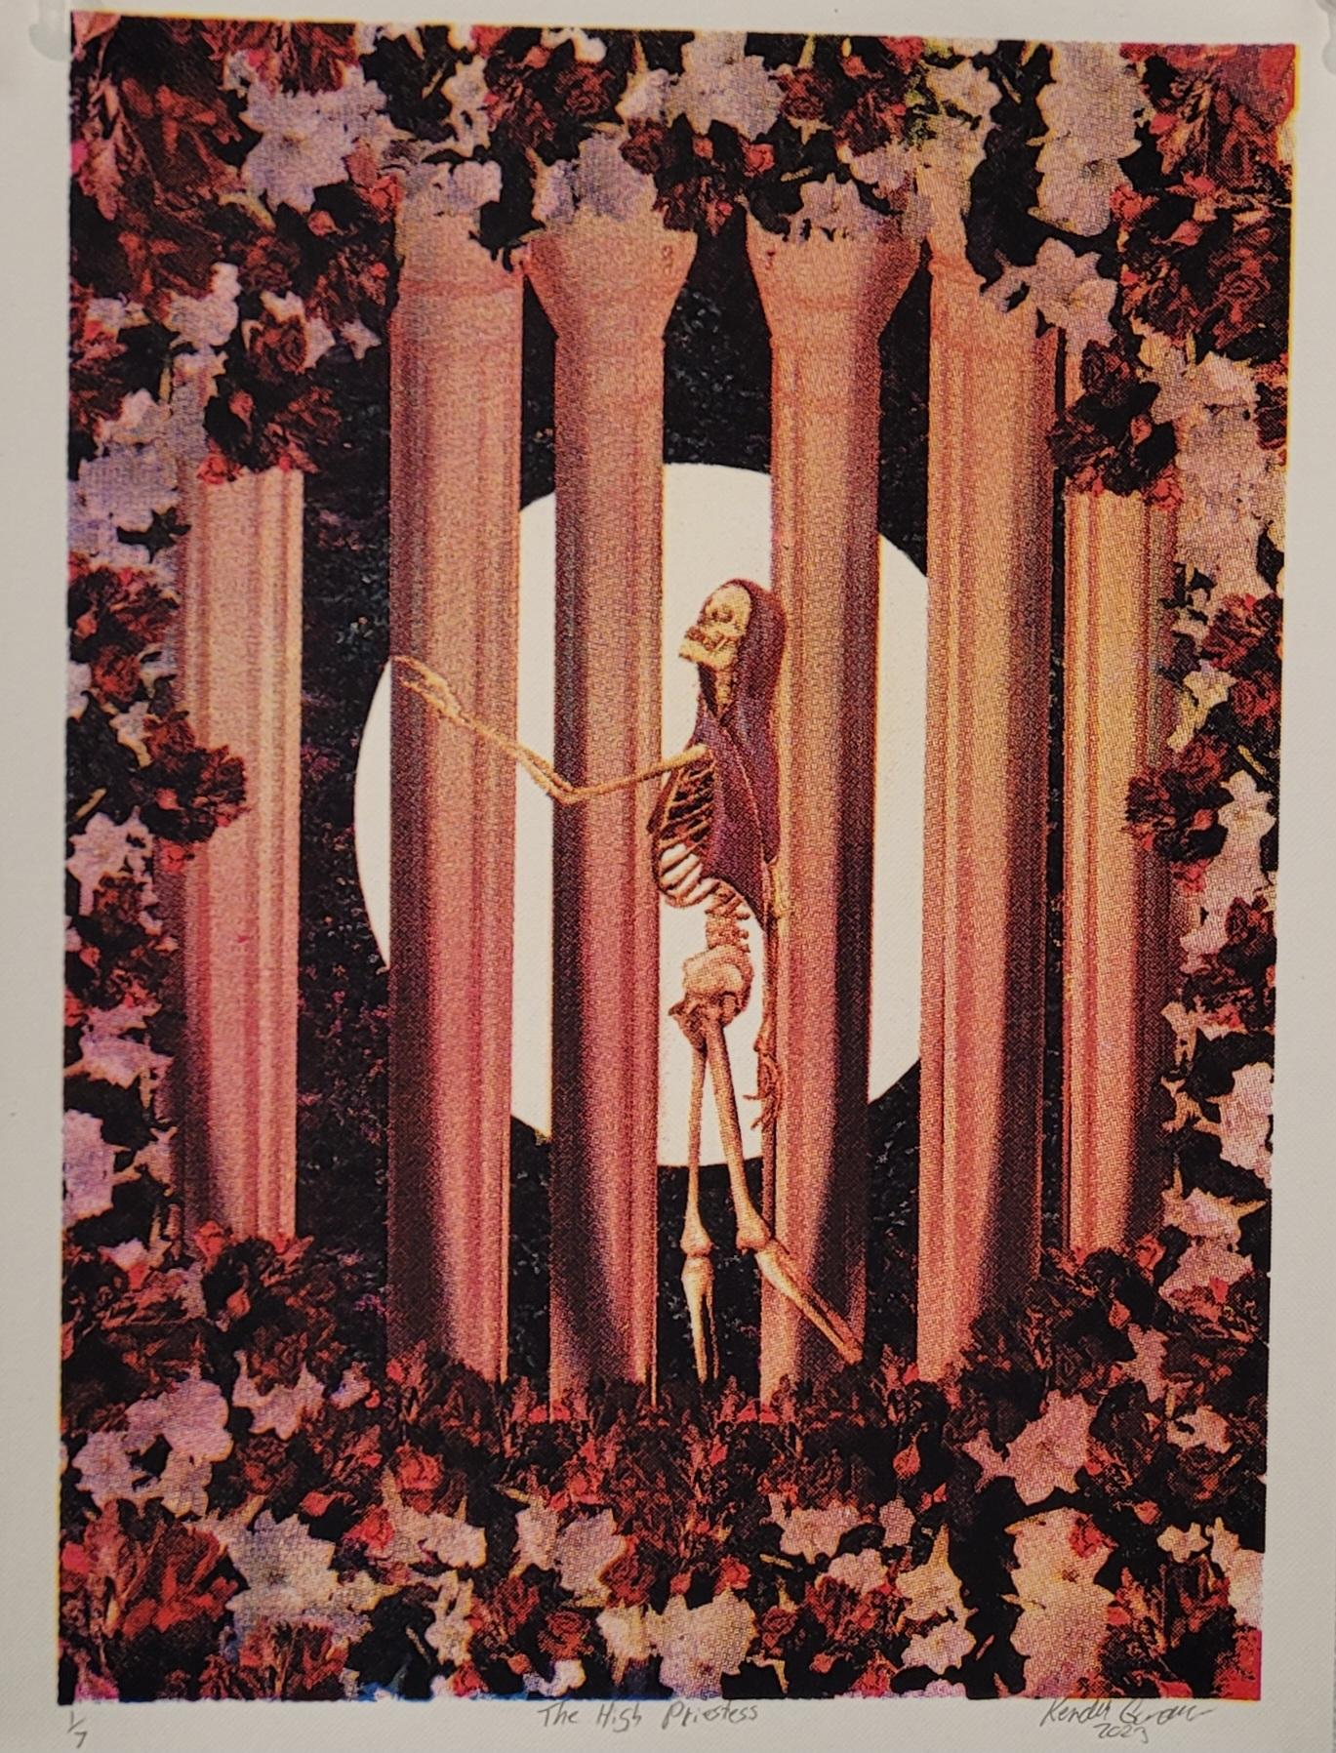 | Kendell Gunderson | The High Priestess | 9x12 inches | 2023 | Silk Screen
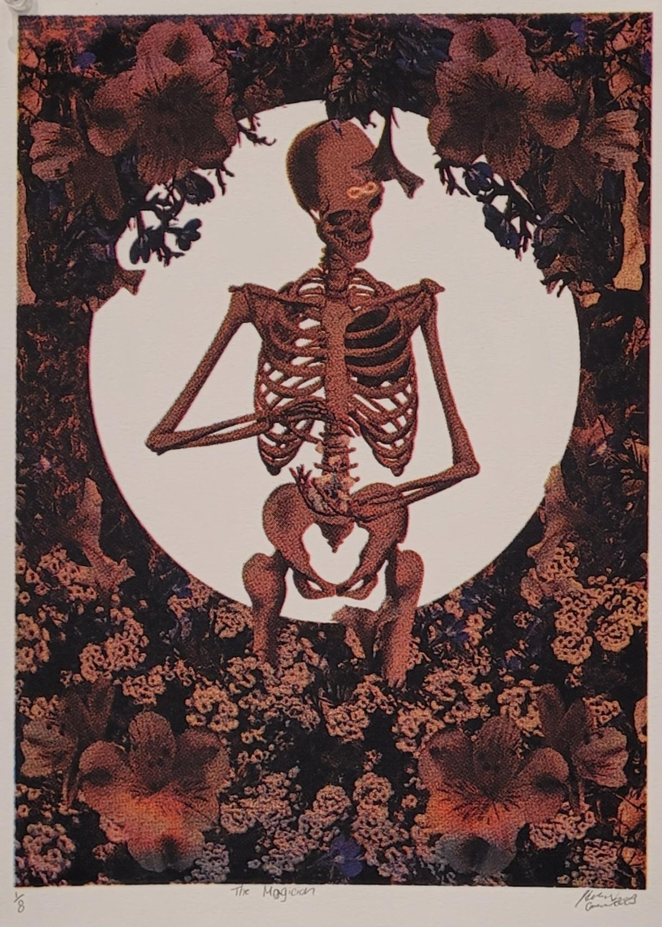 | Kendell Gunderson | The Magician | 9x12 inches | 2023 | Silk Screen
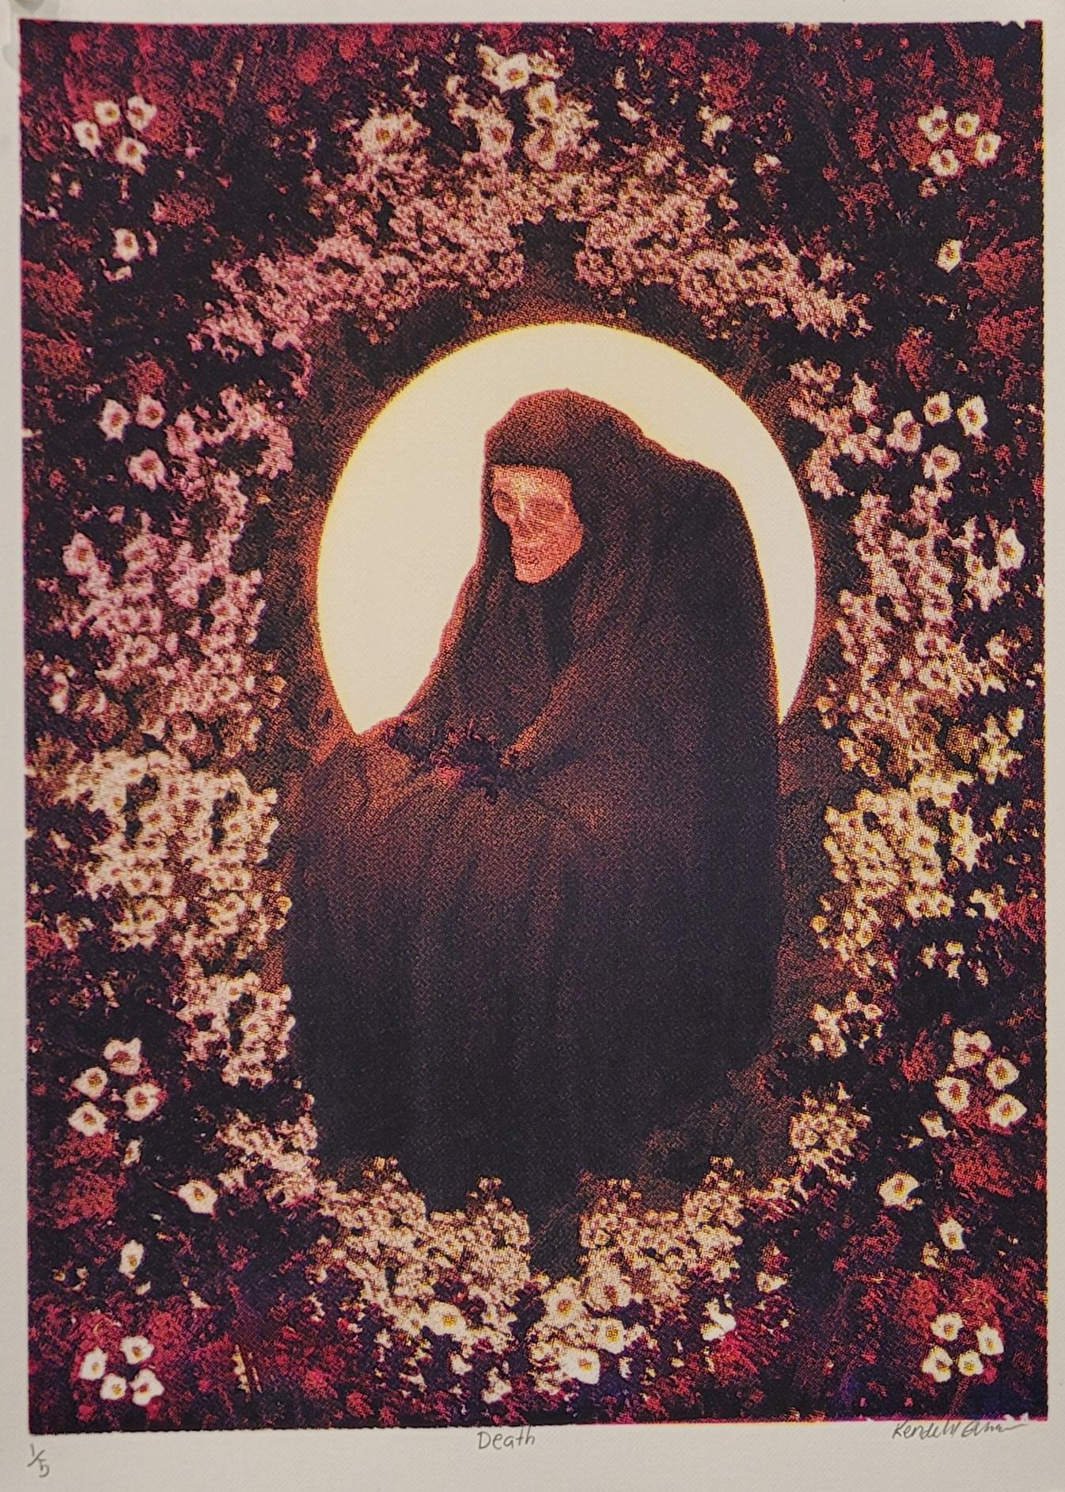 | Kendell Gunderson | Death | 9x12 inches | 2023 | Silk Screen
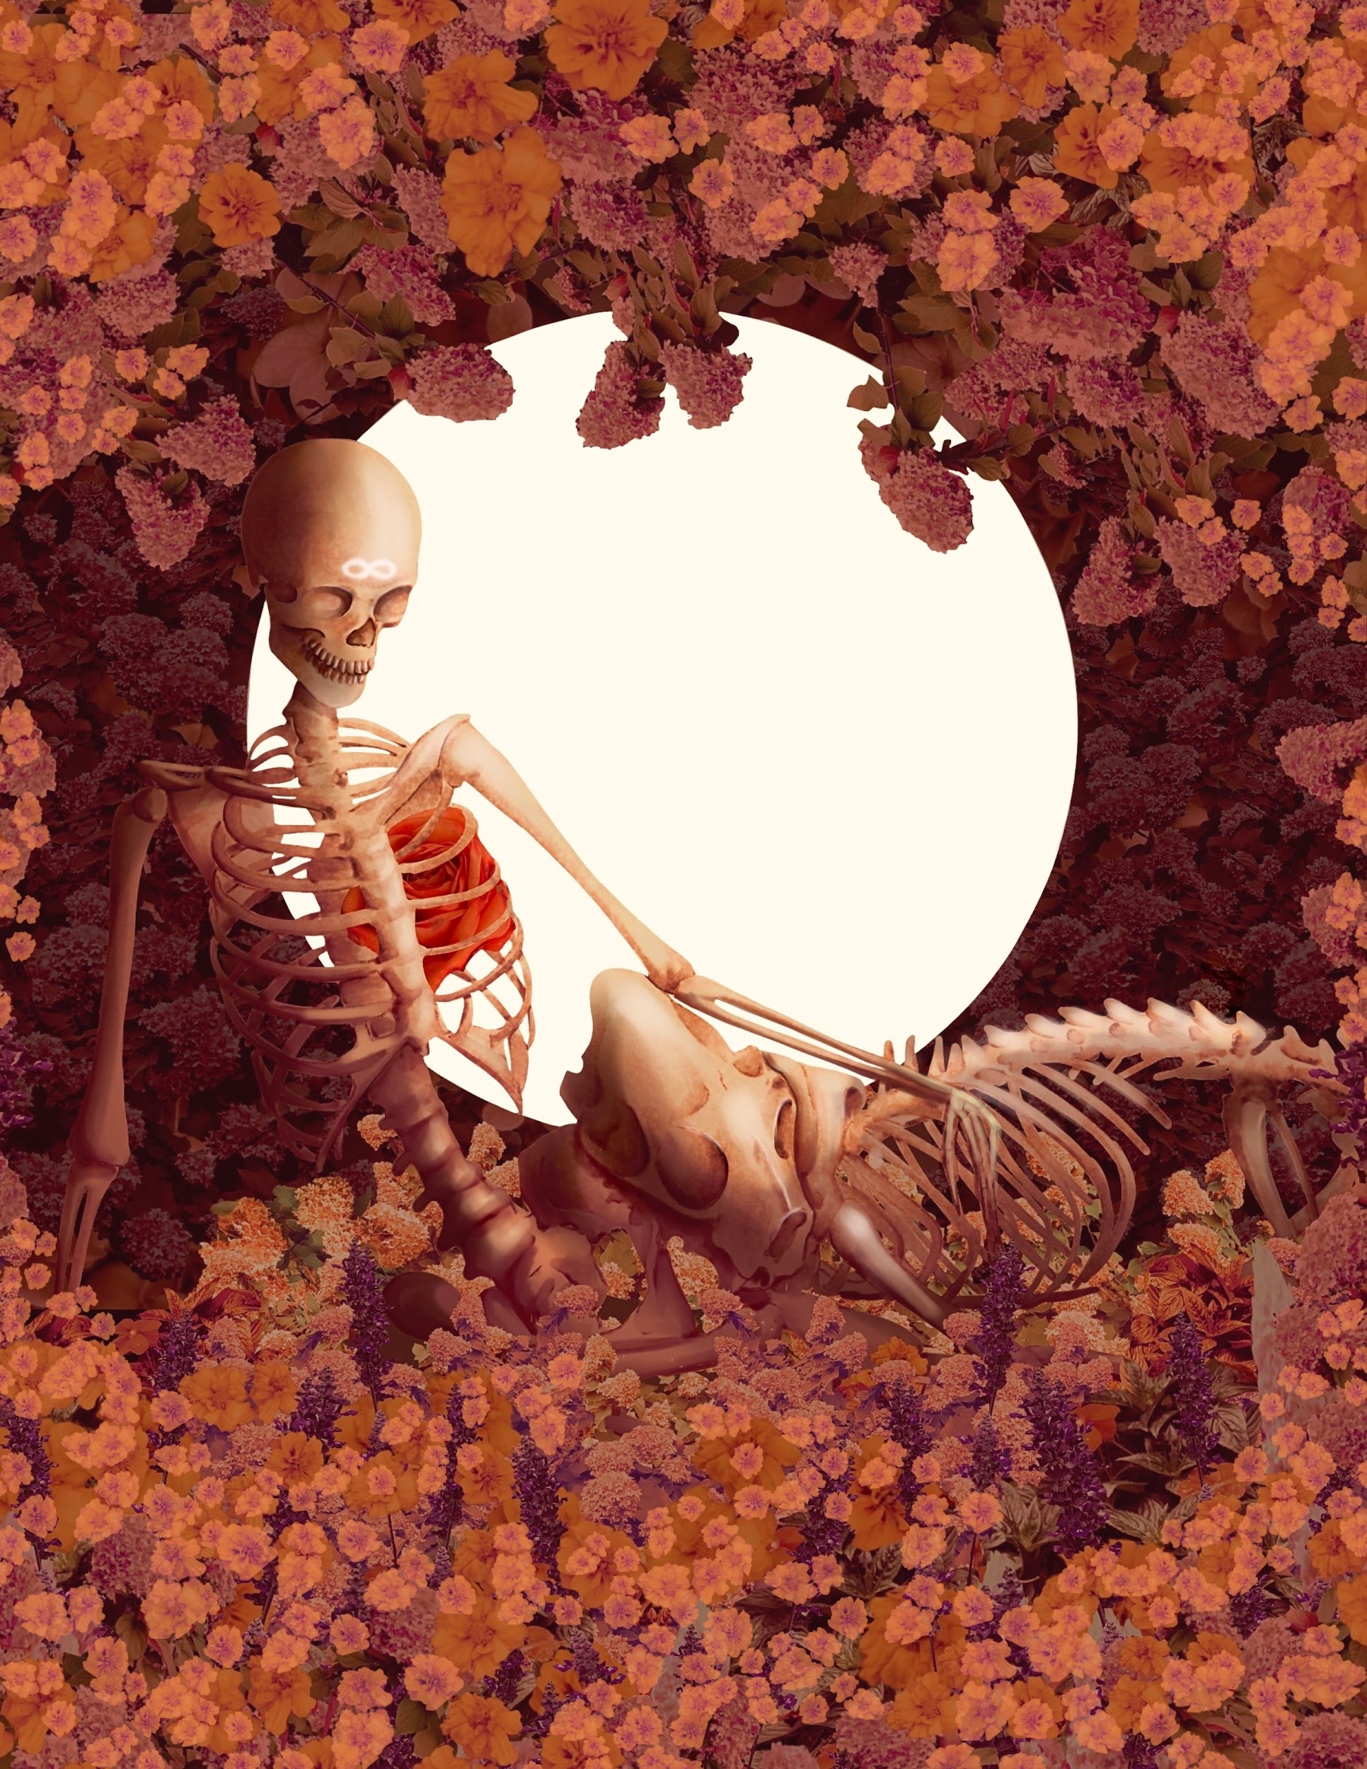 | Kendell Gunderson | Strength | 9x12 inches | 2023 | Silk Screen
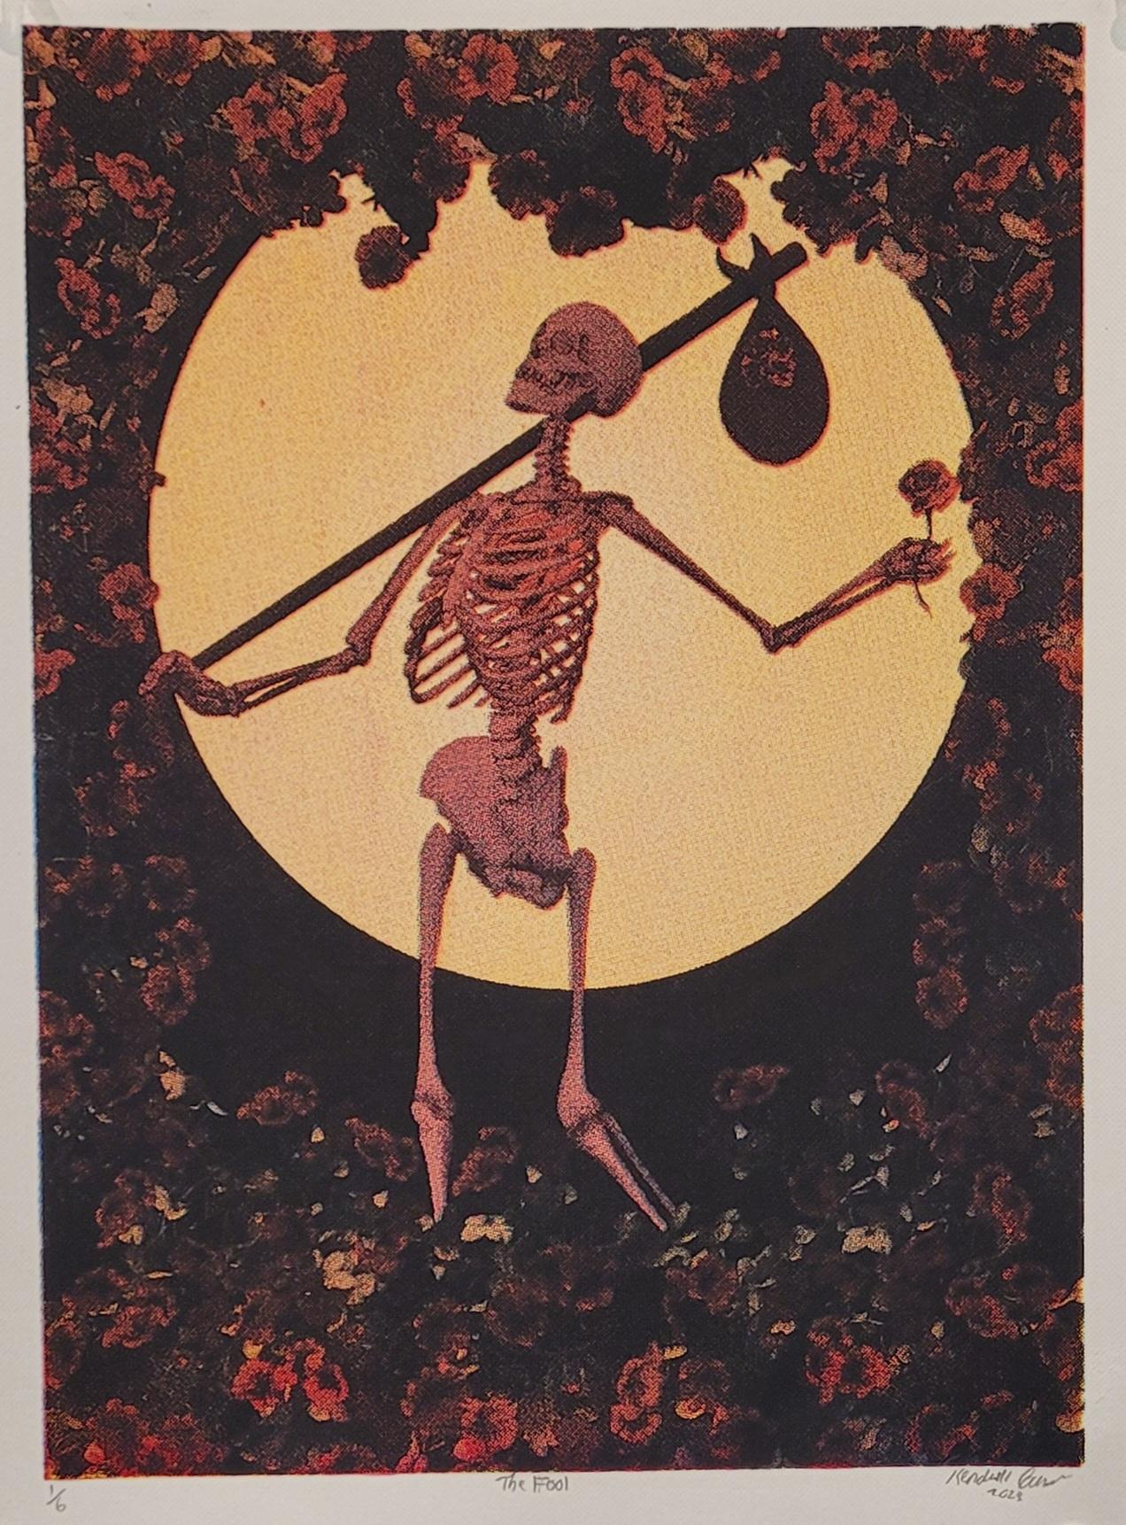 | Kendell Gunderson | The Fool | 9x12 inches | 2023 | Silk Screen
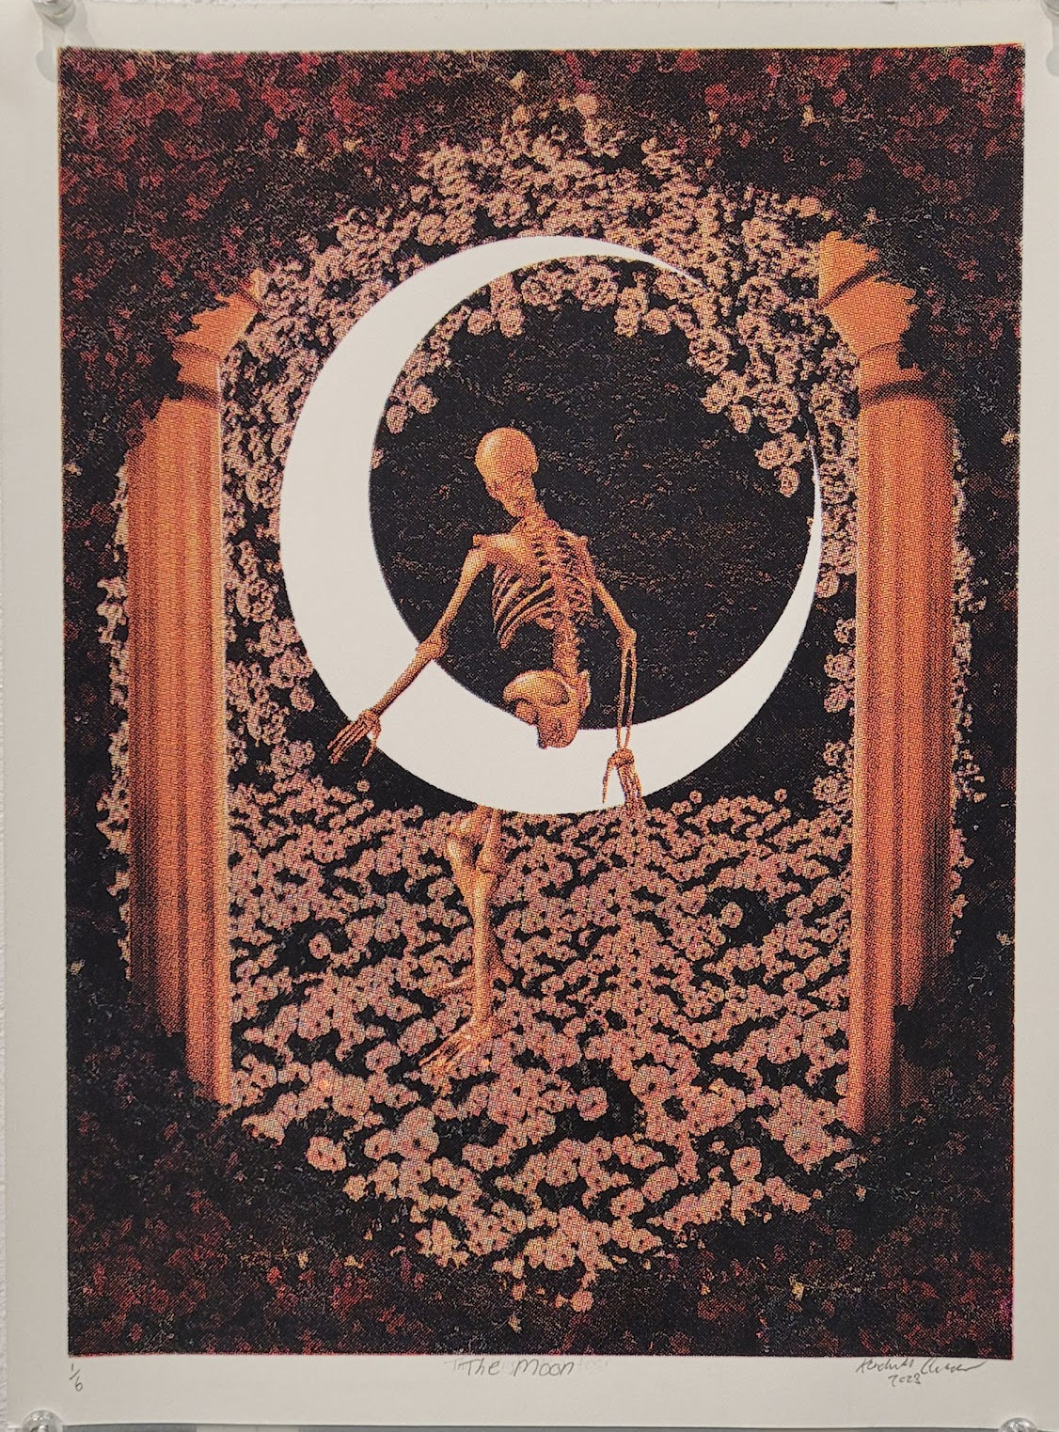 | Kendell Gunderson | The Moon | 9x12 inches | 2023 | Silk Screen
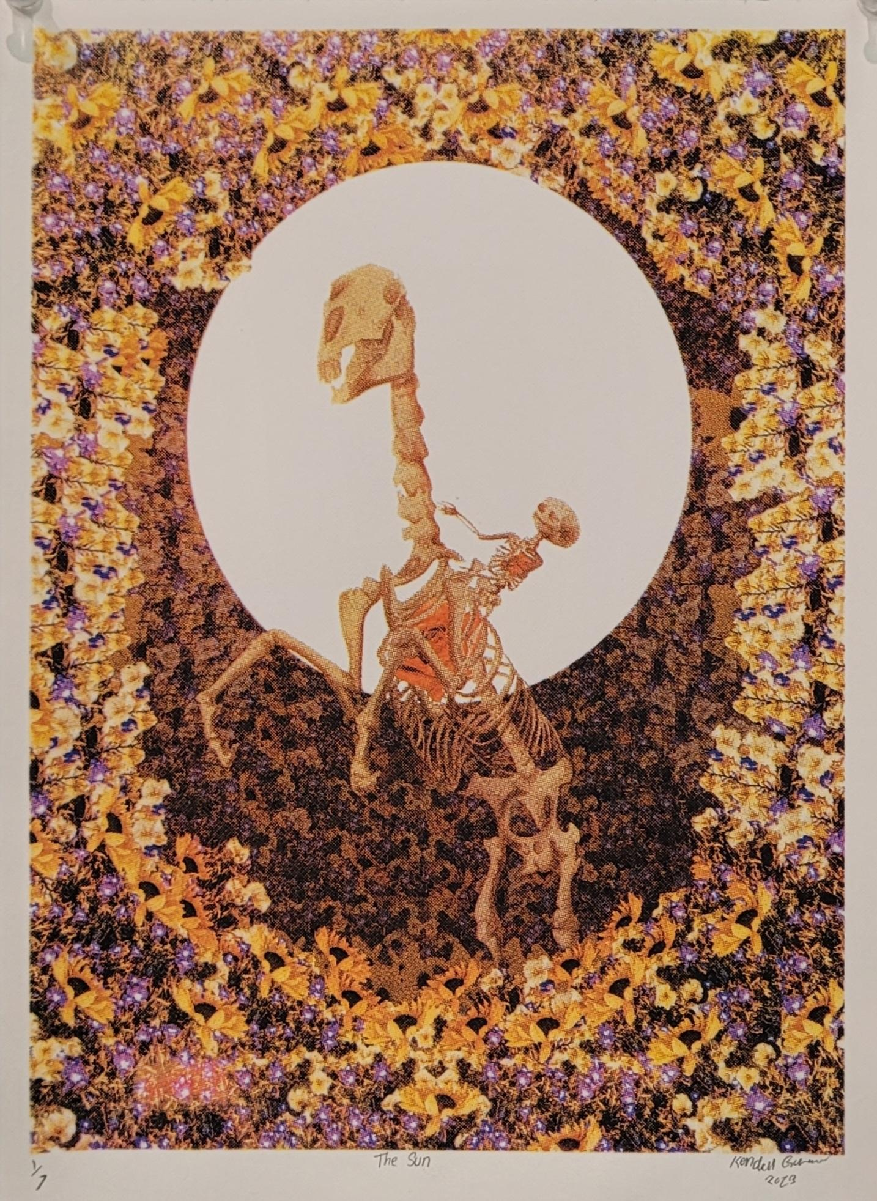 | Kendell Gunderson | The Sun | 9x12 inches | 2023 | Silk Screen
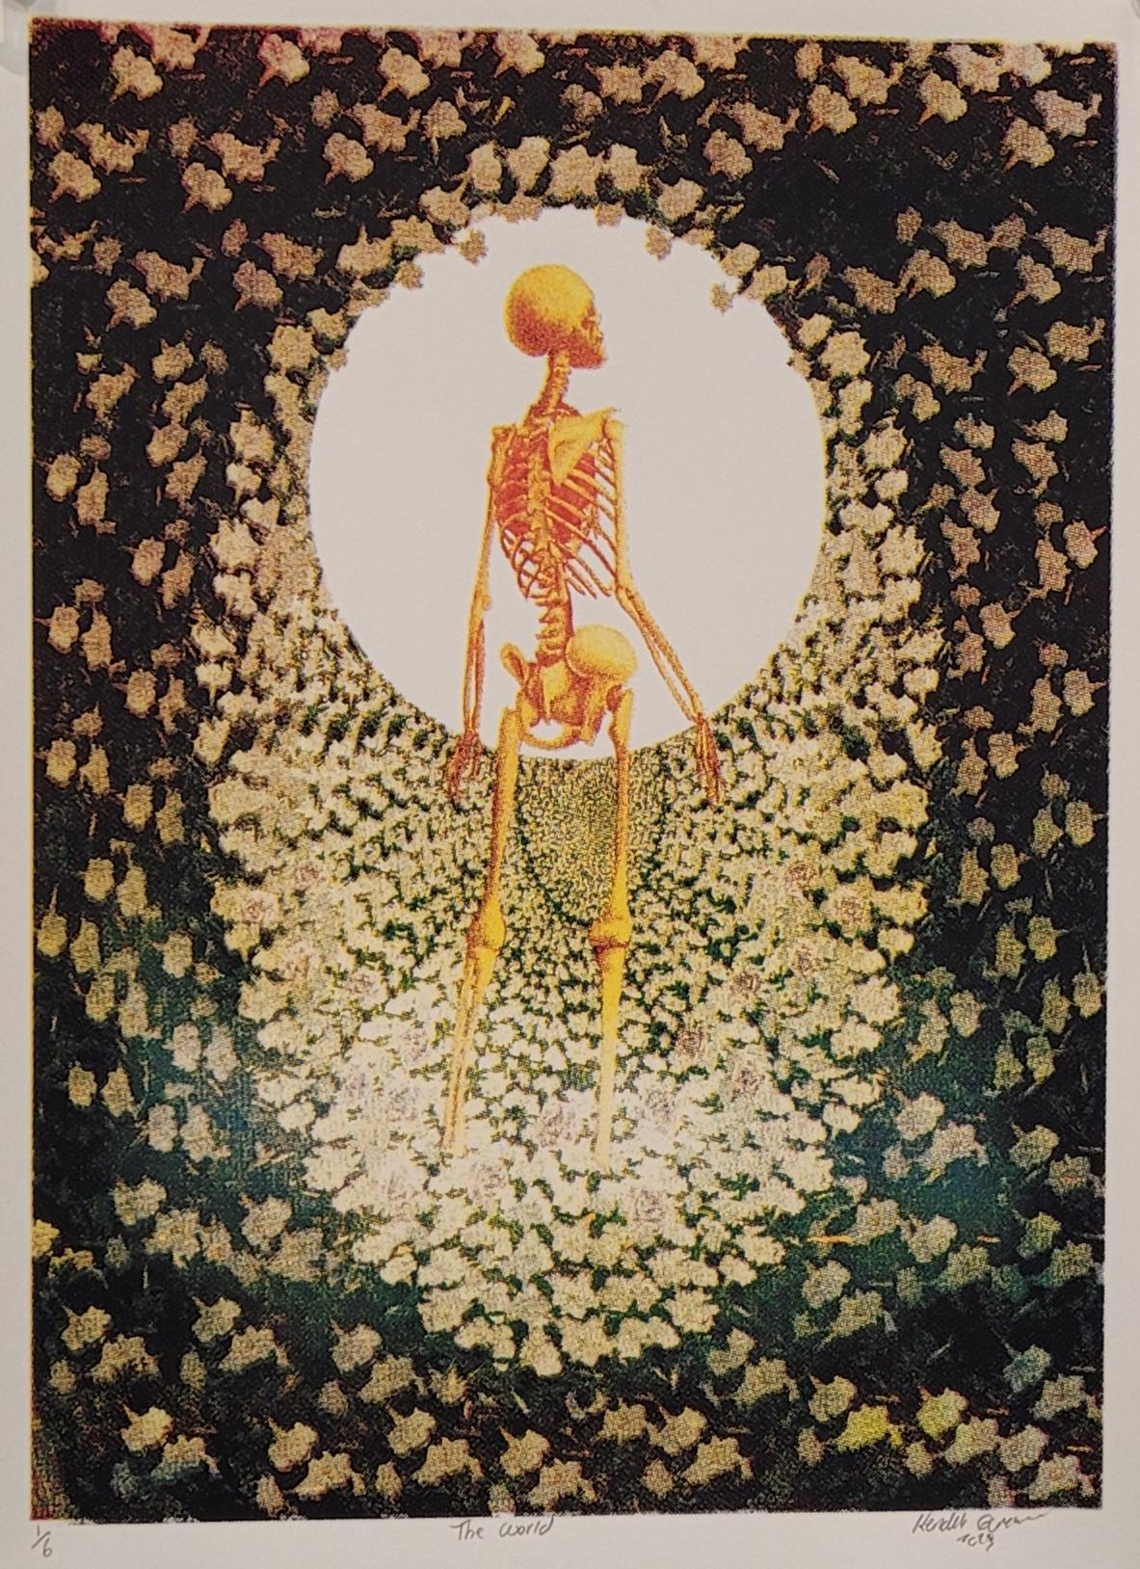 | Kendell Gunderson | The World | 9x12 inches | 2023 | Silk Screen
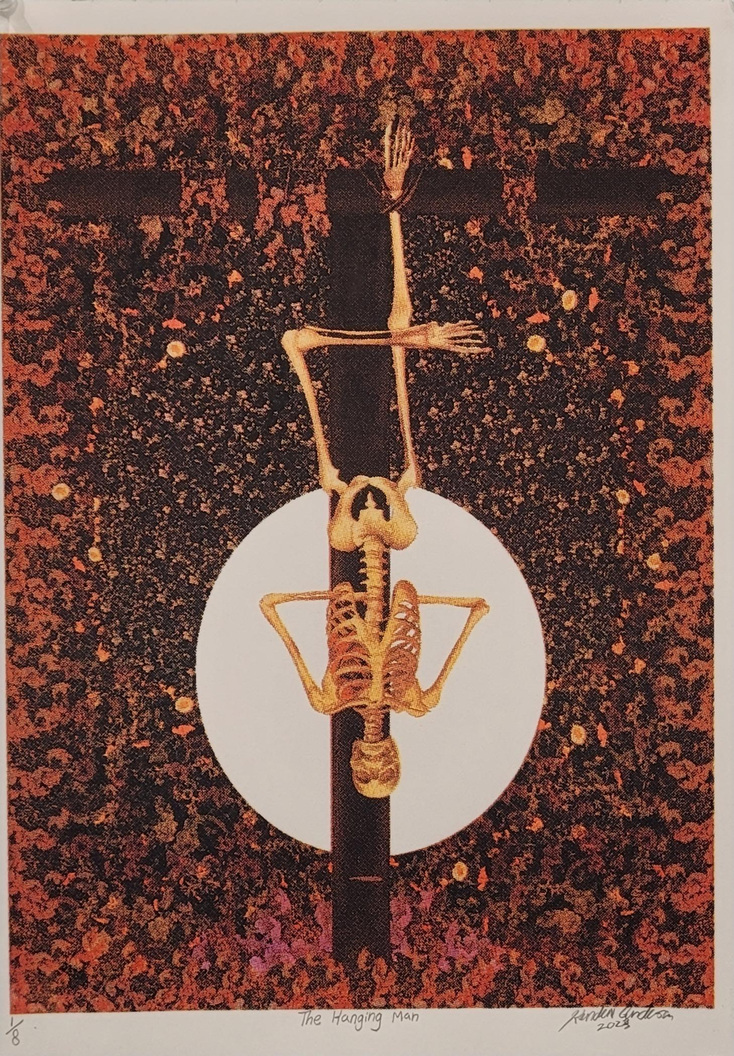 | Kendell Gunderson | The Hanging Man | 9x12 inches | 2023 | Silk Screen
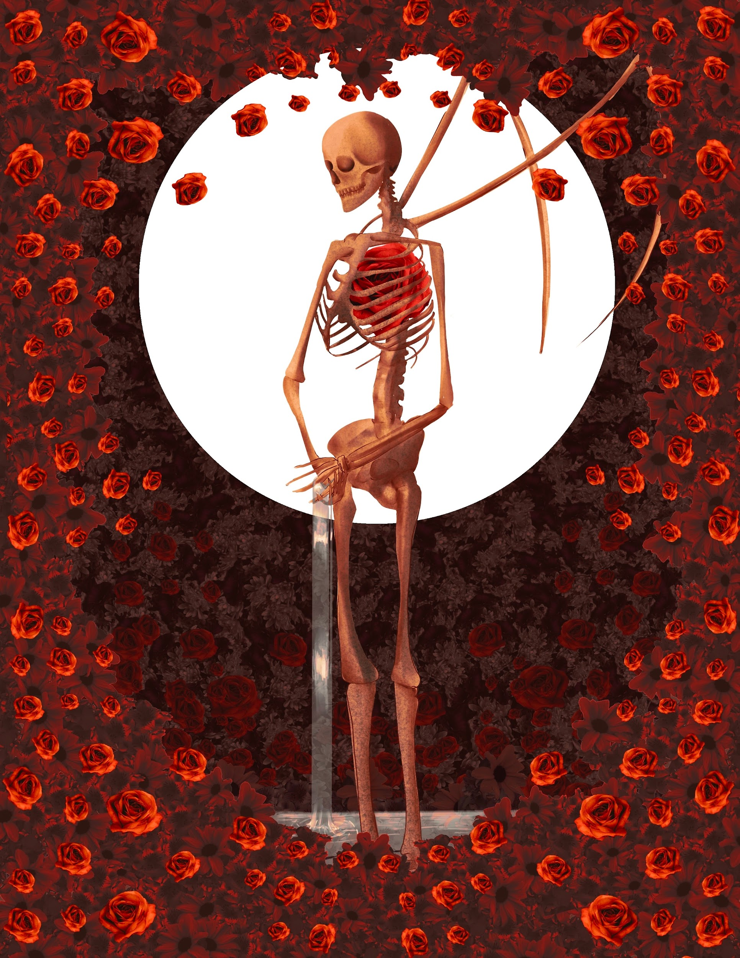 | Kendell Gunderson | Temperance | 9x12 inches | 2023 | Silk Screen
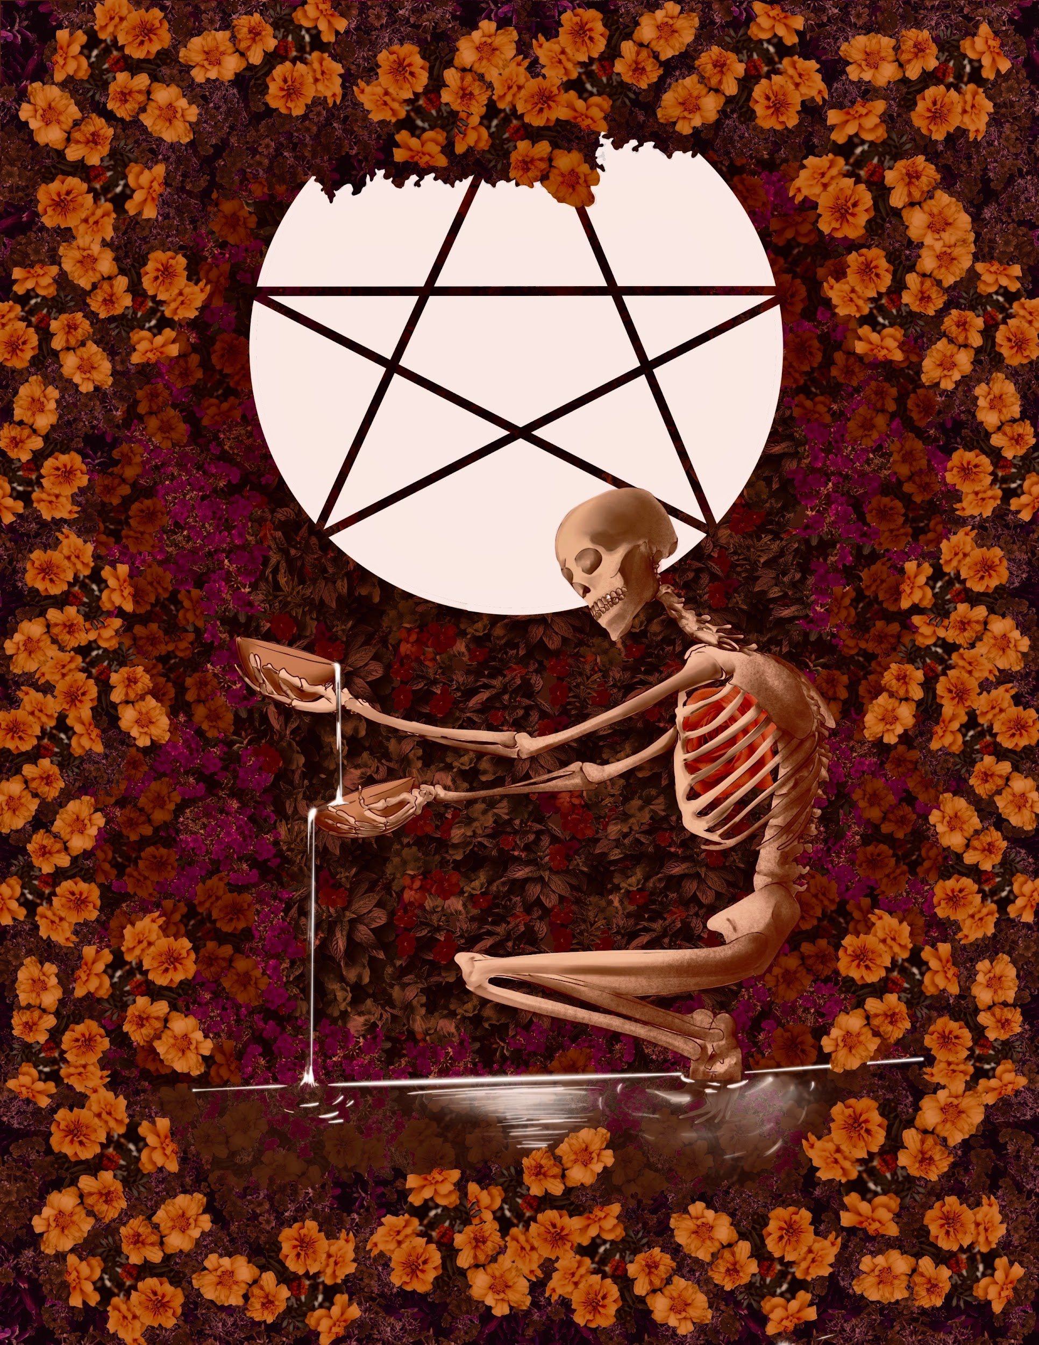 | Kendell Gunderson | The Star | 9x12 inches | 2023 | Silk Screen
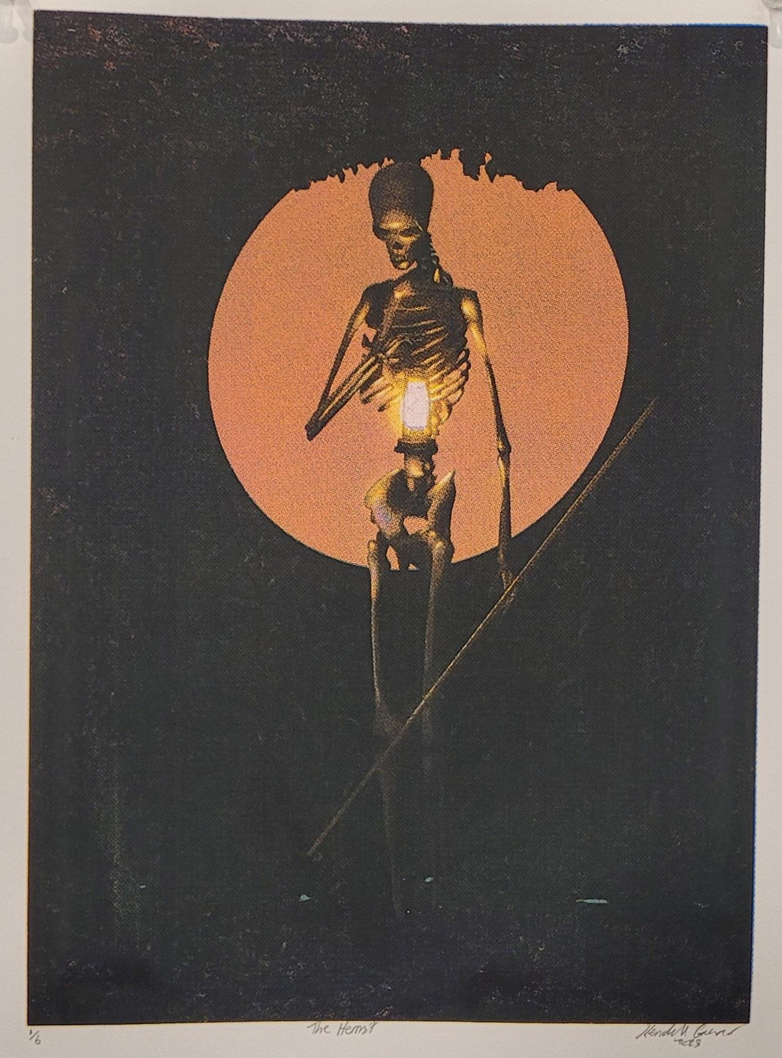 | Kendell Gunderson | The Hermit | 9x12 inches | 2023 | Silk Screen
 | Kendell Gunderson | The Chariot | 9x12 inches | 2023 | Silk Screen
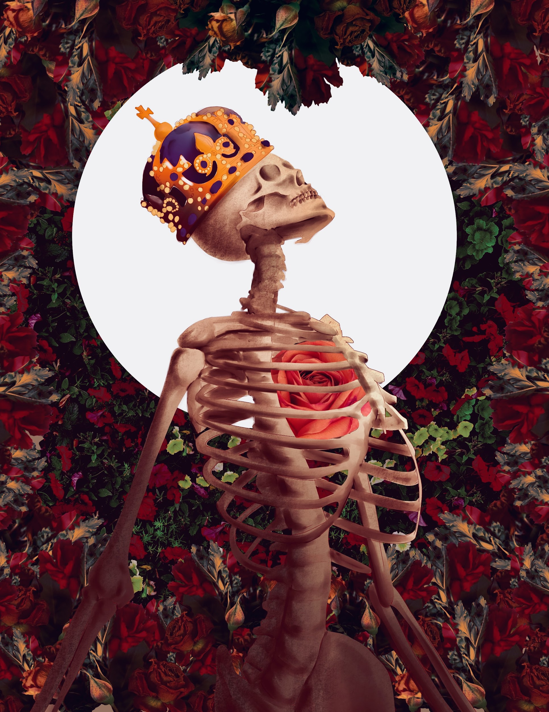 | Kendell Gunderson | The Emperor | 9x12 inches | 2023 | Silk Screen
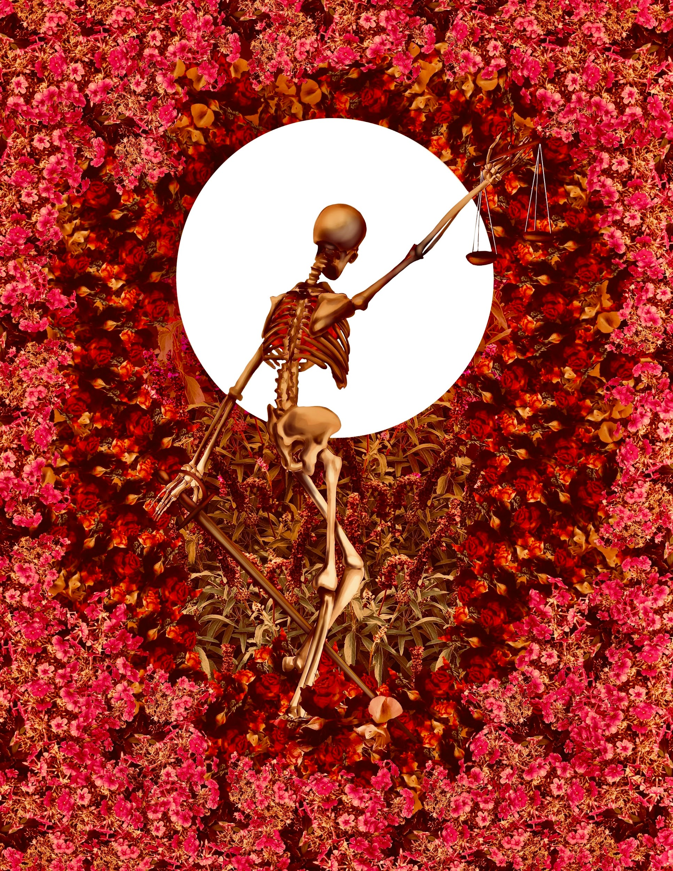 | Kendell Gunderson | Justice | 9x12 inches | 2023 | Silk Screen
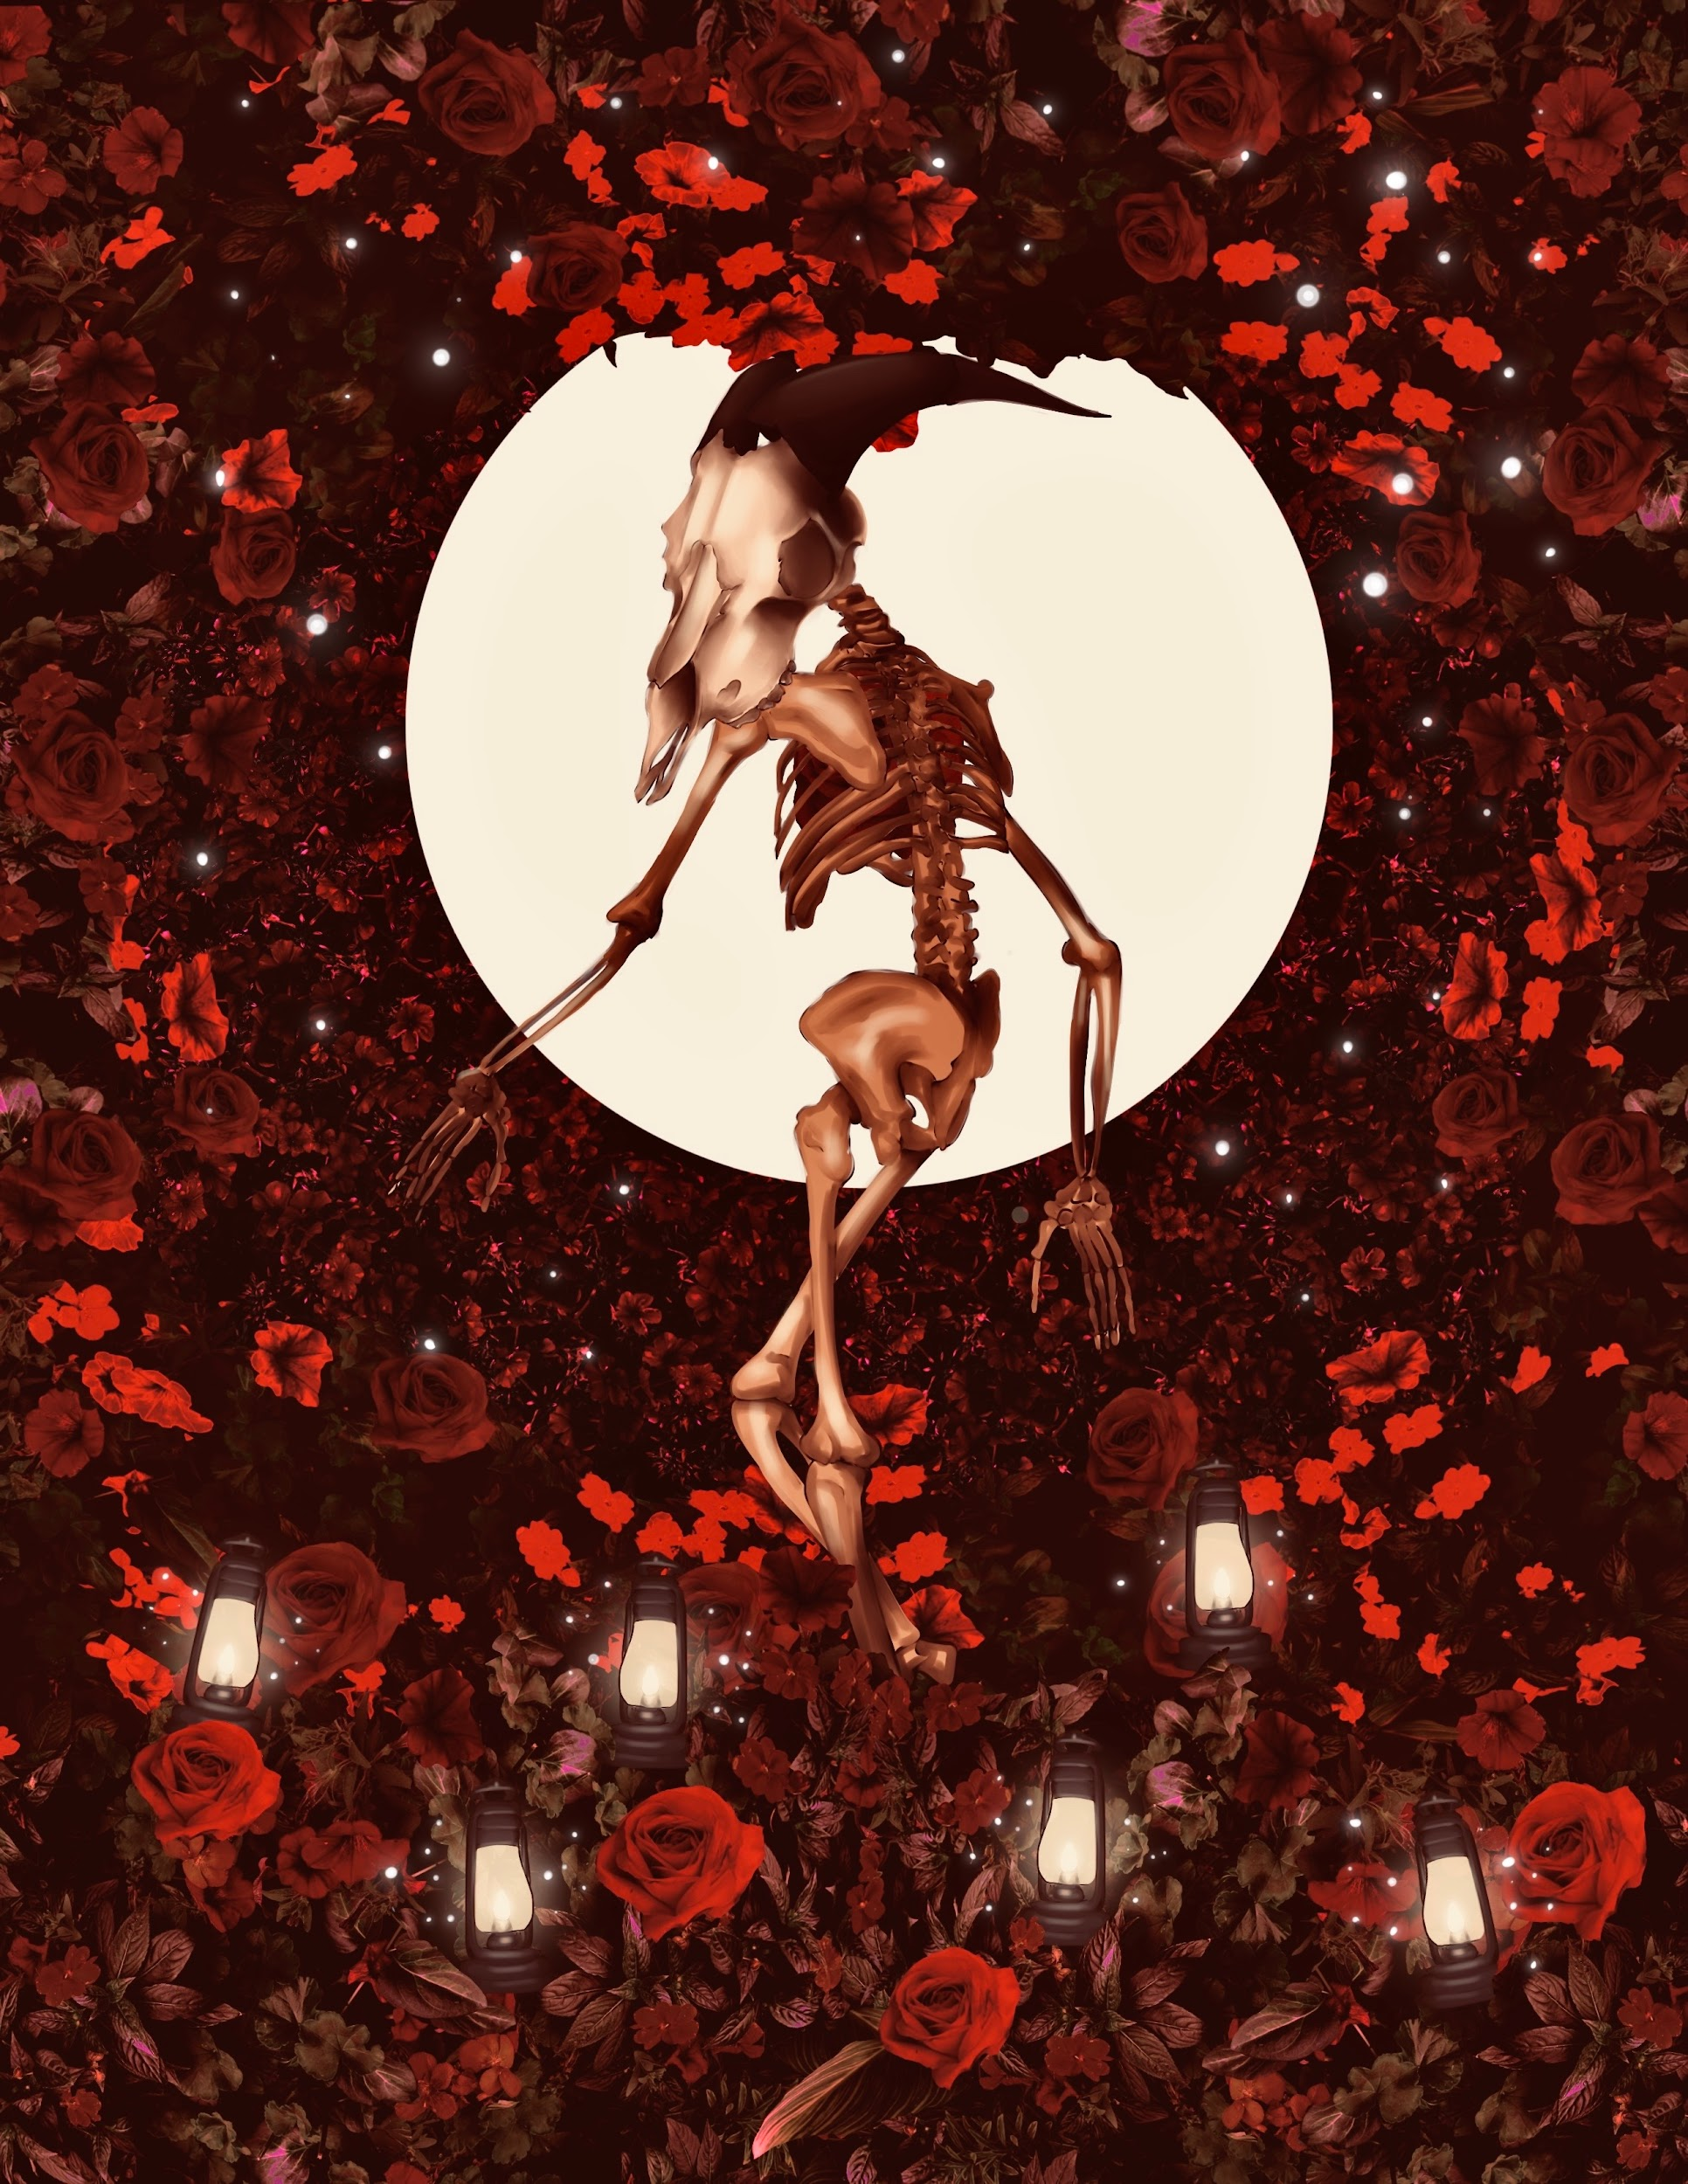 | Kendell Gunderson | The Devil | 9x12 inches | 2023 | Silk Screen
 | Kendell Gunderson | Judgement | 9x12 inches | 2023 | Silk Screen
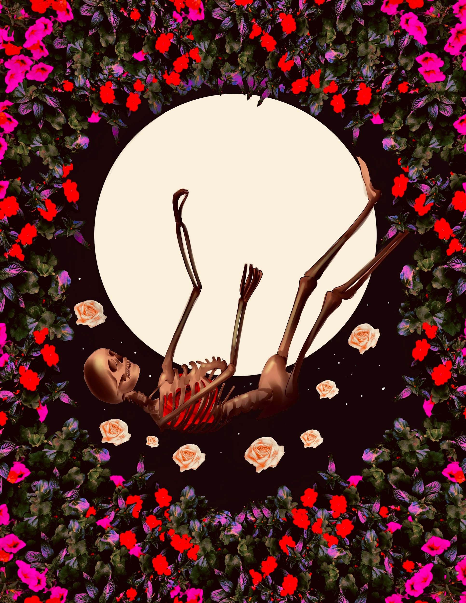 | Kendell Gunderson | The Tower | 9x12 inches | 2023 | Silk Screen

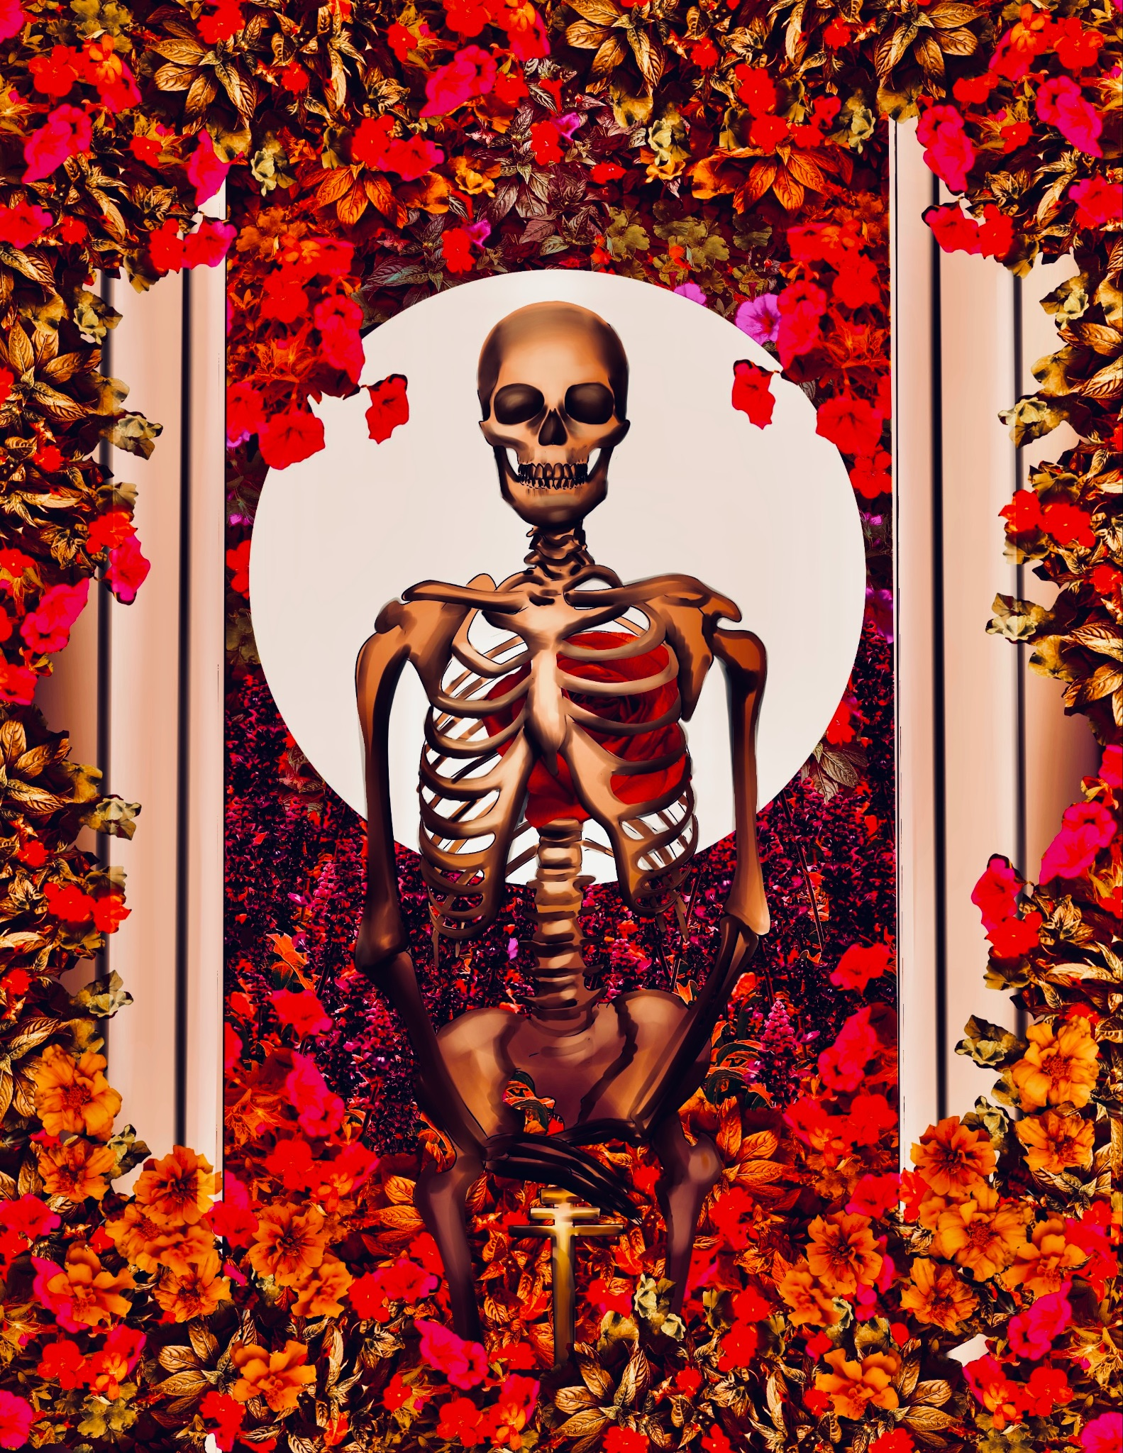 | Kendell Gunderson | The Hierophant | 9x12 inches | 2023 | Silk Screen
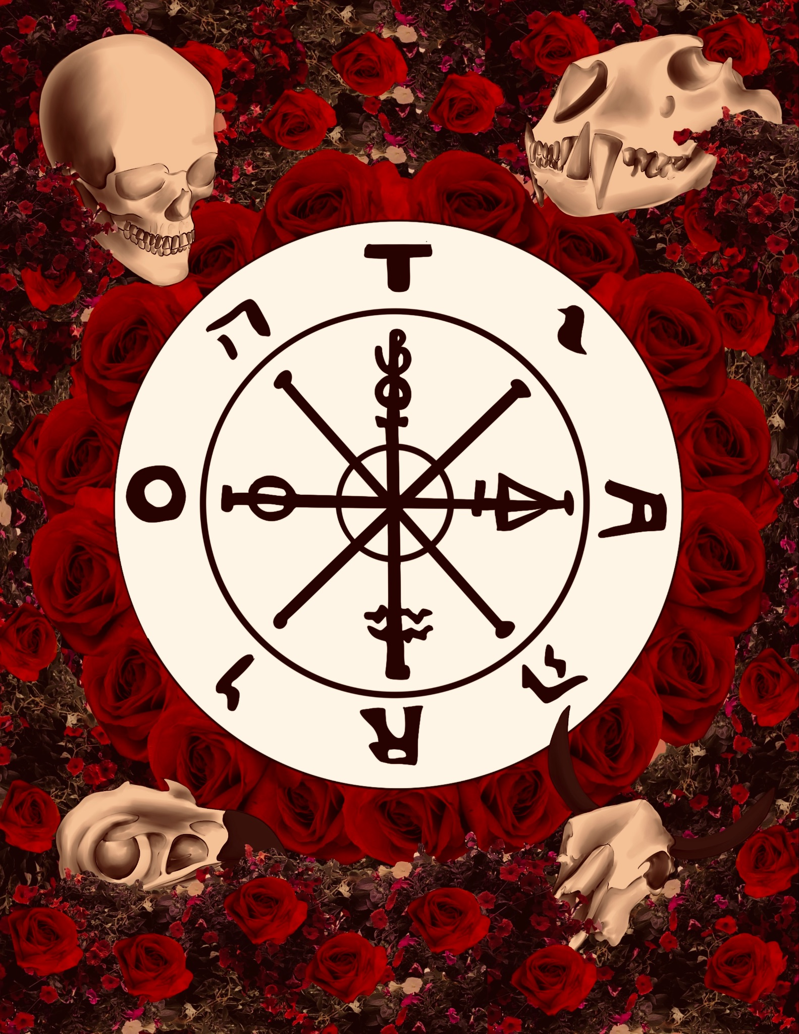 | Kendell Gunderson | Wheel of Fortune | 9x12 inches | 2023 | Silk Screen
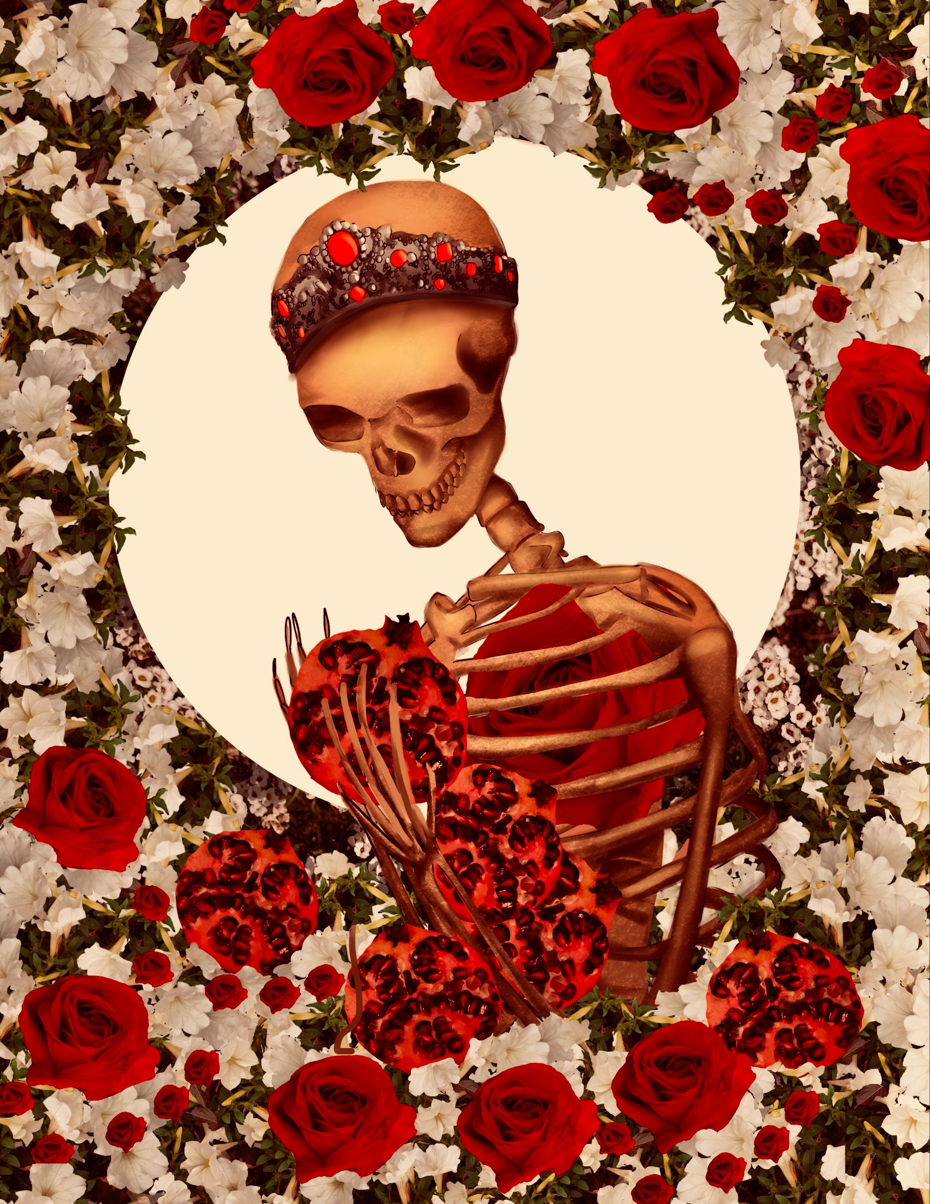 | Kendell Gunderson | The Empress | 9x12 inches | 2023 | Silk Screen
 | Kendell Gunderson | Donate | 8x10 Inches | 2023 | Acrylic on glass
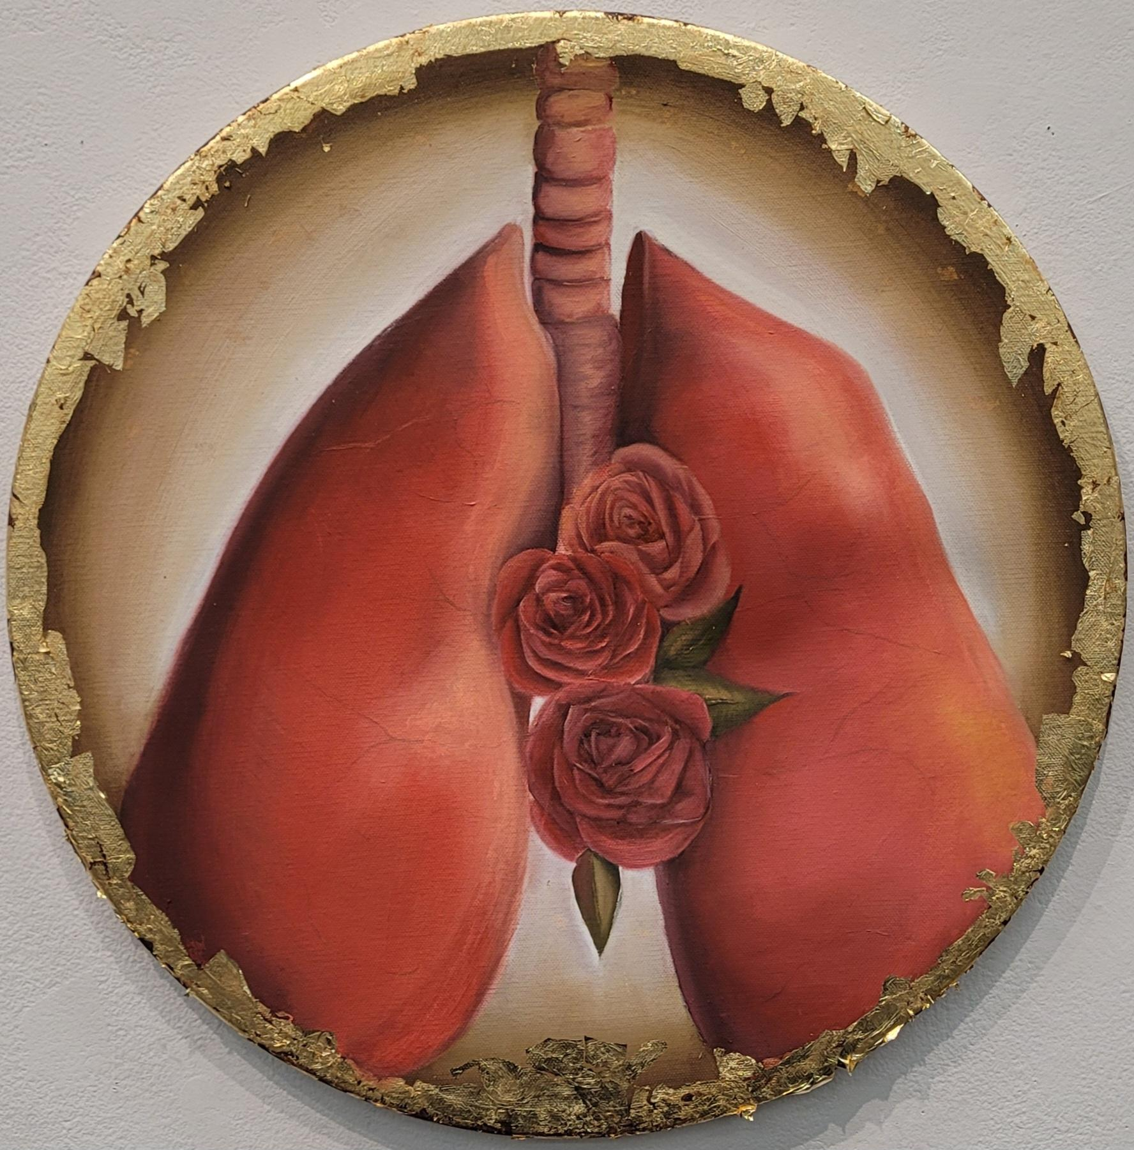 | Kendell Gunderson | Pulmonis | 12 Inches | 2023 | Oil on canvas
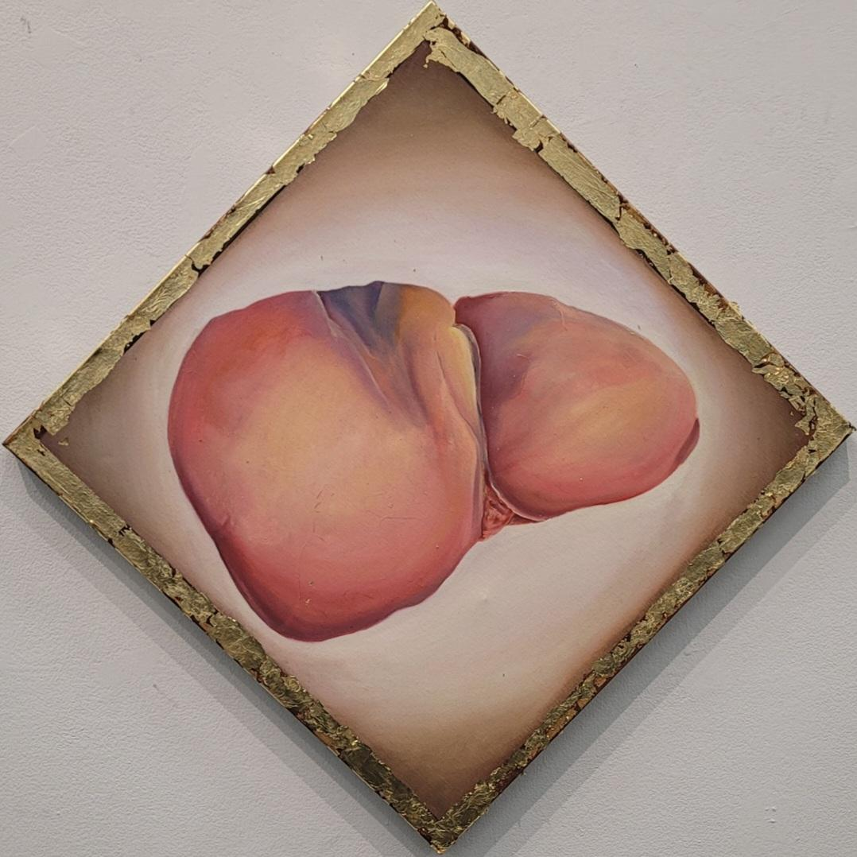 | Kendell Gunderson | Iecur | 24x24 Inches | 2023 | Oil on canvas
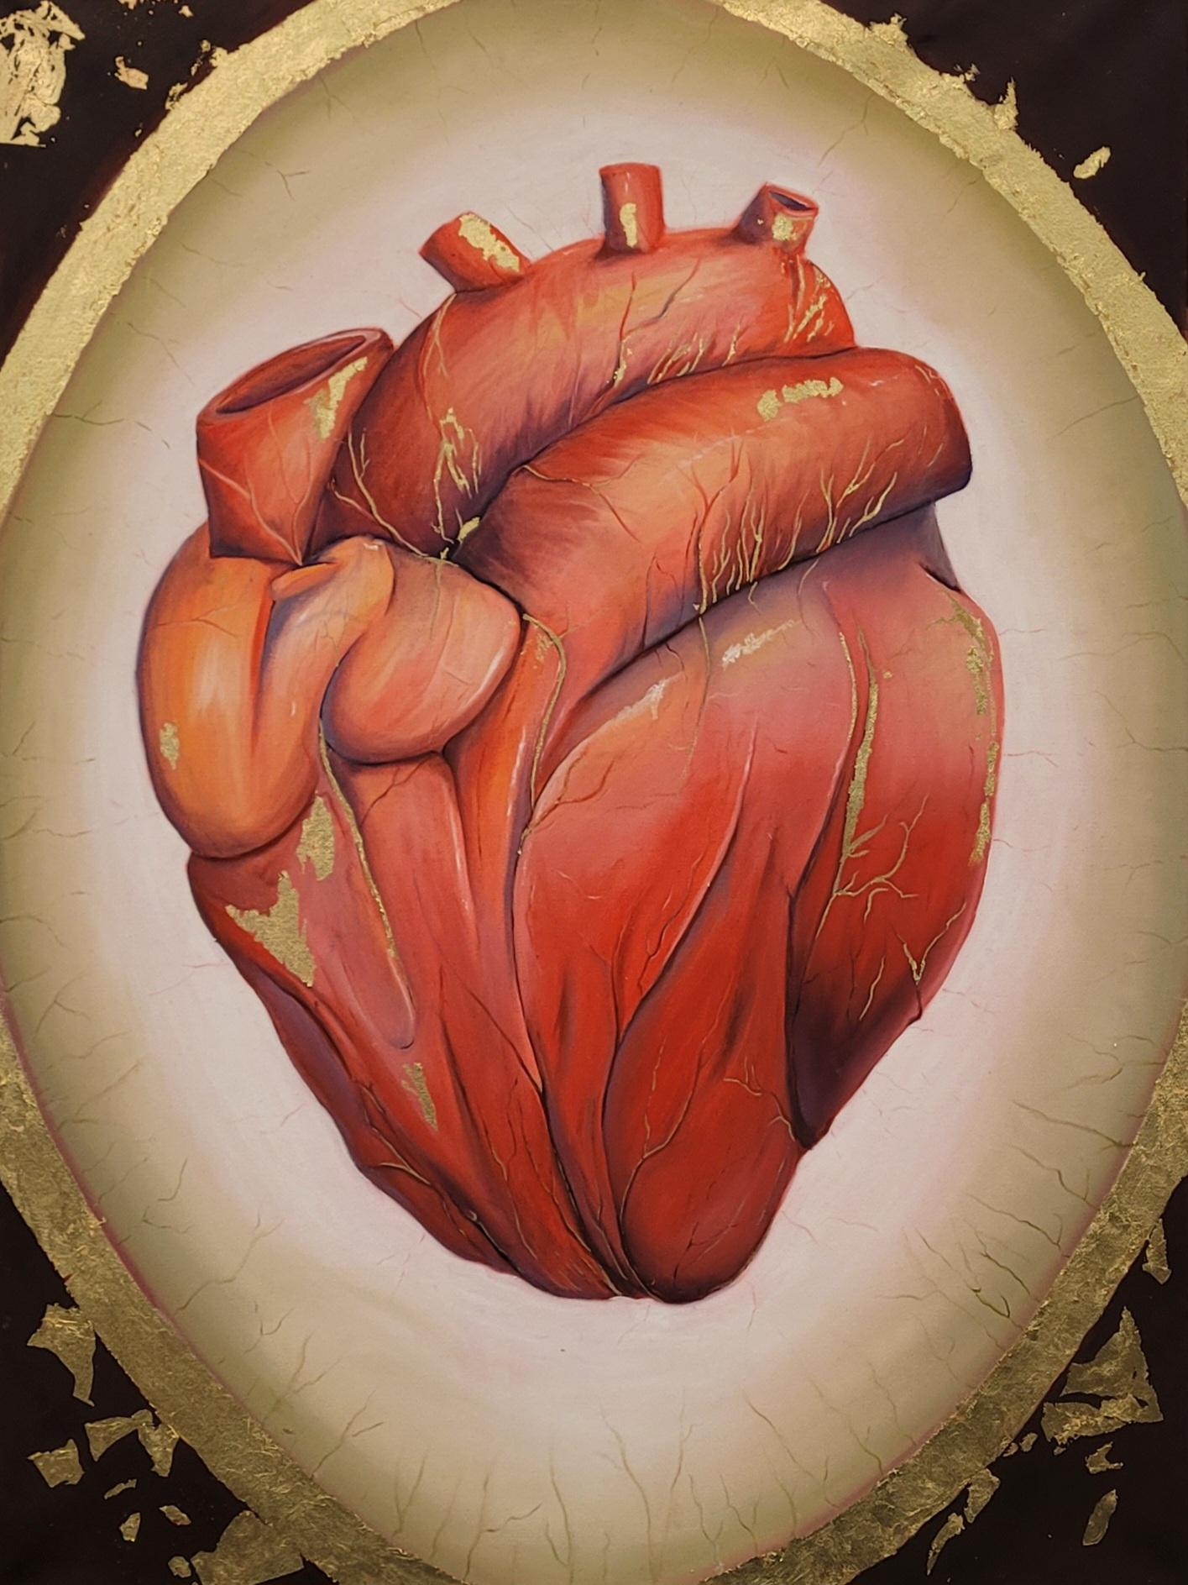 | Kendell Gunderson | Cor | 30x40 Inches | 2022 | Oil on canvas
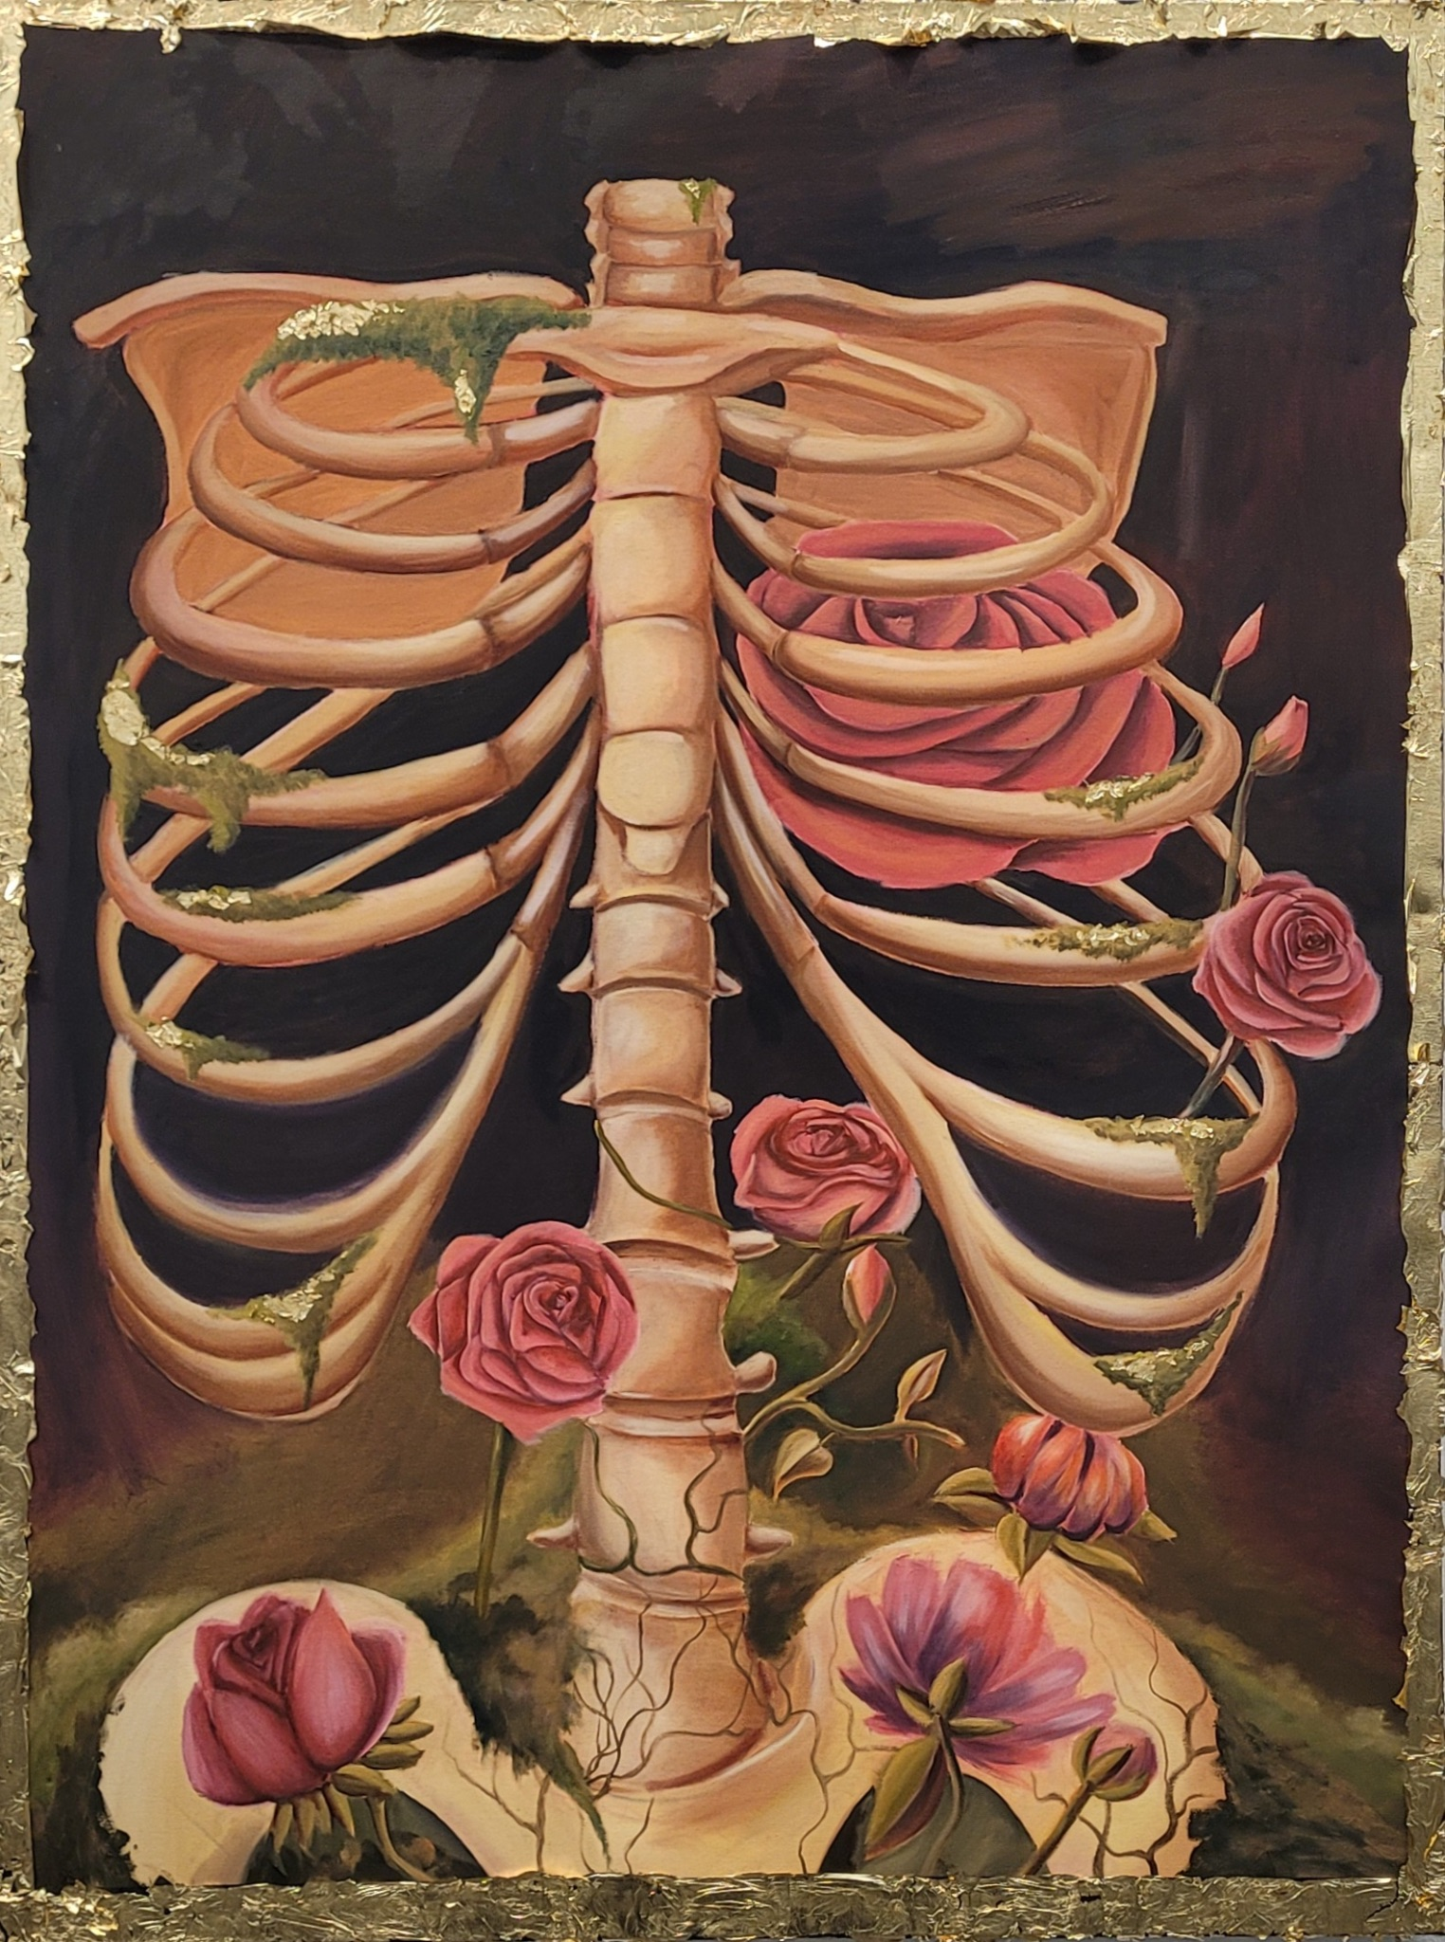 | Kendell Gunderson | Cavea Thoracis | 48x60 Inches | 2023 | Oil on canvas
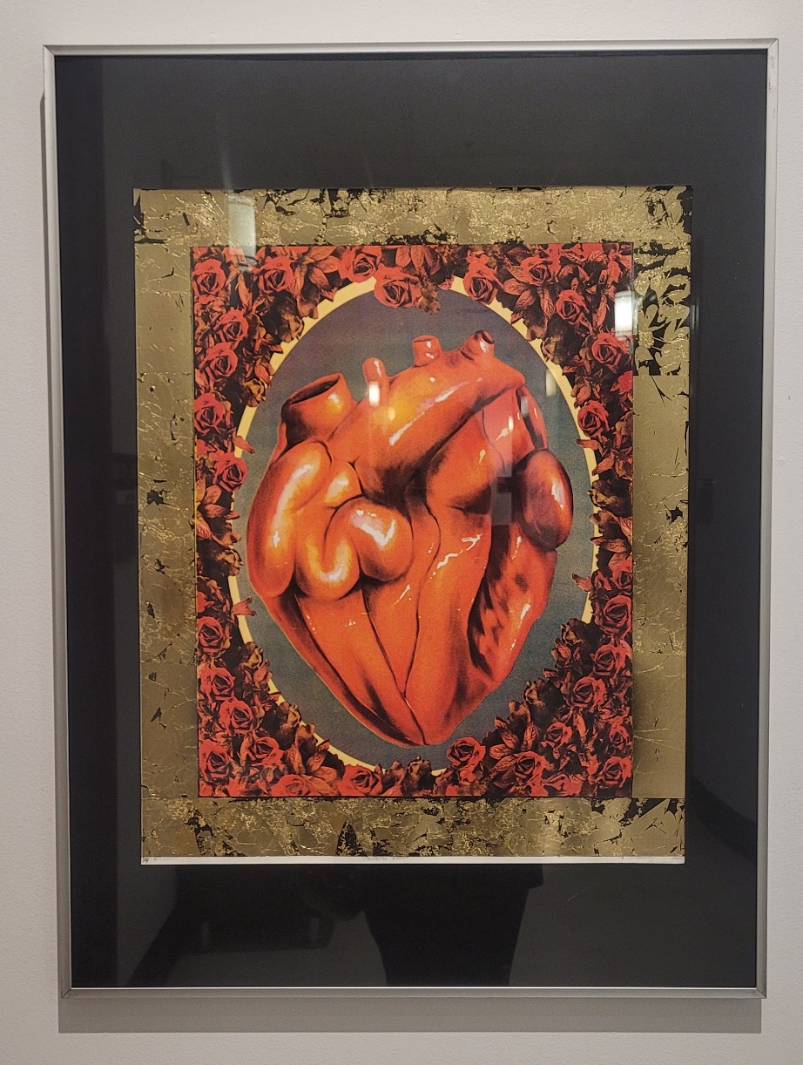 | Kendell Gunderson | Memento Viver | 24x30 Inches | 2023 | Silk Screen

